

Rockets OOSC LIMITED

Welcome to Rockets OOSC Limited out of school club where
‘Every Child Matters’

Rockets OOSC Limited is an established out of school club which has been running for the past Fourteen years and our before school club has been running for the past 7 years. In order for us to provide your child/children with the very best care we have written this parent pack so that you can understand how we work and how you can help us. We hope that your child/children have a happy and rewarding time with us here at Rockets.

Our aim at Rockets OOSC Limited is to provide a happy, safe, warm and stimulating environment for all children to play, learn and develop freely with confidence and enjoyment. Each child is valued as an individual. We will help children to develop responsibility for themselves and their actions to become competent, confident, independent and co-operative individuals.
We will also encourage children to have a positive attitude and respect for both themselves and others. We want to promote a positive relationship with parents/carers and work in partnership with them to provide high quality learning, play and care for your child/children.

Rockets OOSC Limited is committed to meeting the needs of parents and carers by Listening and responding to their views and concerns, keeping them informed of our policies and procedures, including opening times, fees and charges, and programmes of activities.
Sharing and discussing their child’s achievements, experiences, progress and friendships, along with any difficulties that may arise.

Rockets OOSC Limited is committed to providing:

- Care and activities that put the needs and safety of children first.
- A programme of activities that is interesting, educational, stimulating and fun.
- Activities that promote each child’s social, physical, moral and intellectual behaviour.
- Access to a variety of facilities and equipment under safe and supervised conditions.
- A staff team that is experienced, well trained and properly supported.
- An environment where no child is bullied or suffers discrimination in any form.


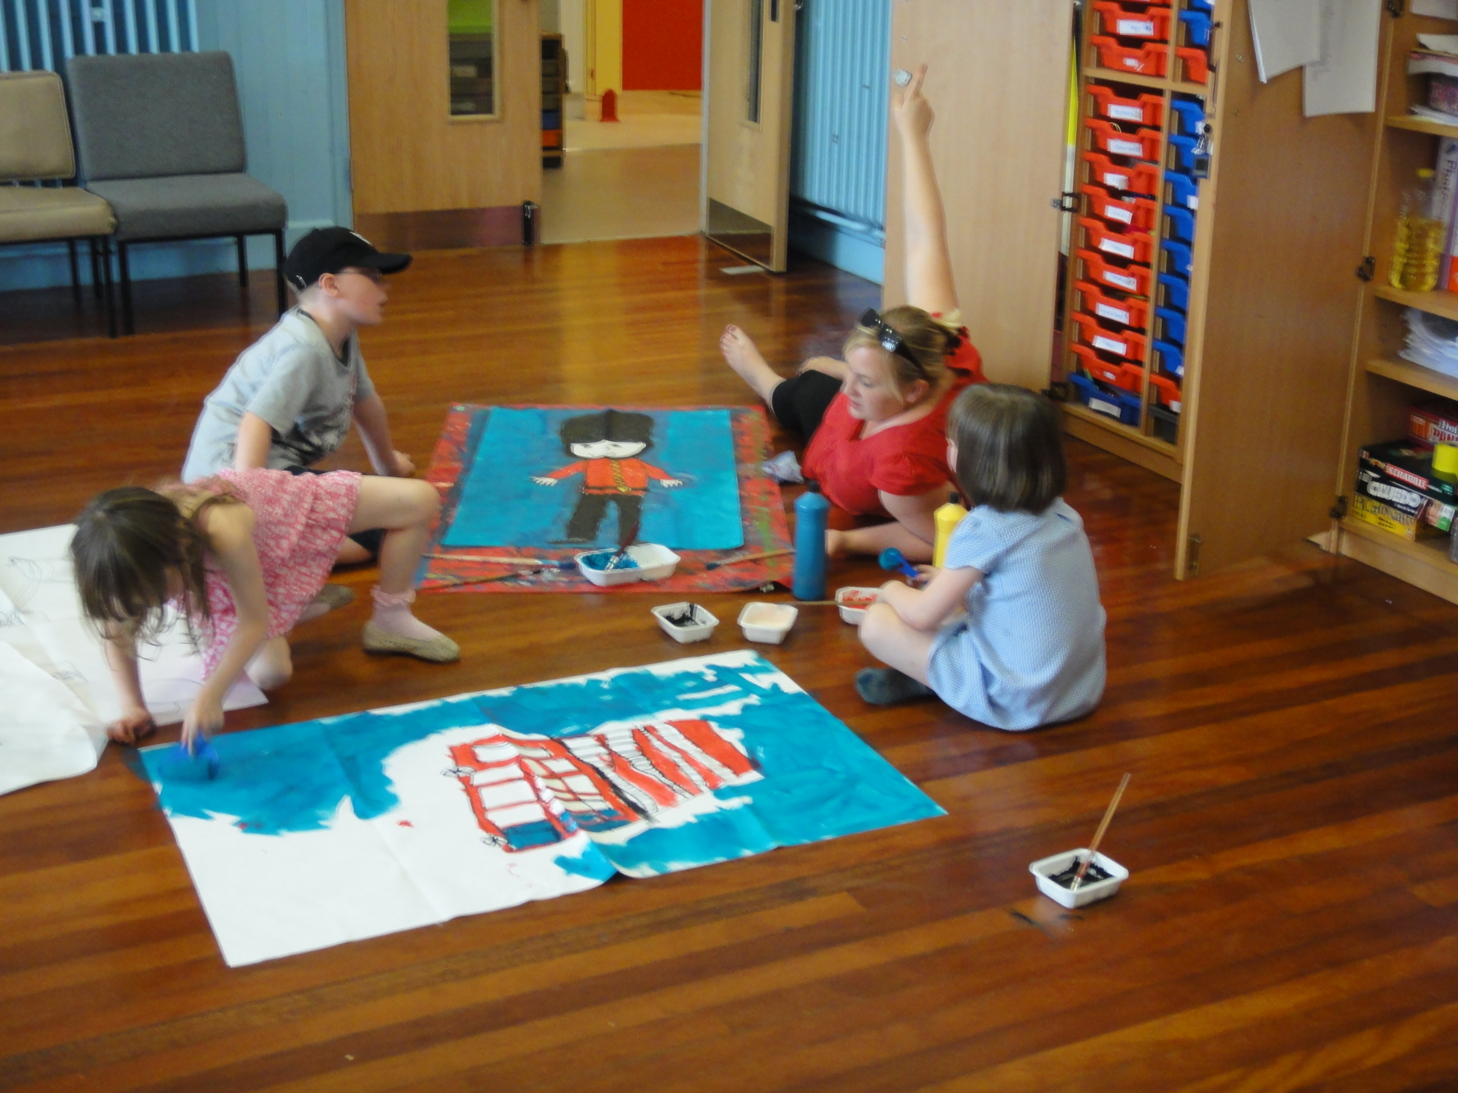
Learning through play and play is learning:


Rockets OOSC Limited provide a well-planned and organised play environment that offers children rich and stimulating experiences, alongside opportunities to explore, experiment, plan and make decisions for them selves. The programme of activities will recognise and take into account the differing ages, stages, interests, backgrounds and abilities of the children. Activities are carefully planned to allow children to build on their natural curiosity, advance their thinking, use their imagination and develop positive social relationships. At all times, the club will recognise a child’s individuality, effort and achievement. Wherever possible, children will be involved in the process of planning activities so that the programme reflects their opinions, and so that children feel some ownership over the club.

The overarching aim of the EYFS is to help young children achieve the five EVERY CHILD MATTERS outcomes of staying safe, being healthy enjoying and achieving, making a positive contribution, and achieving economic well-being.

Involving and consulting children:

Rockets OOSC Limited and all its members of staff are committed to the principles of involving and consulting children whenever decisions are made within the club that affect them. We at Rockets believe that actively promoting the participation of the children in decision making process is beneficial to children, staff and the club as a whole.

What about before school club? Blastoff

Our before school club opens at 8am at a cost of just £3.50, this runs in the same hall as our after school club, please ring the bell on the purple double doors on arrival.

What happens at the before school club? Blastoff

Mel, Jane and Alison run the before school club 5 days a week, a range of activities are available to all children who attend and toast and cereal is provided for those who wish to have breakfast before school.

All children must be registered with Rockets OOSC Ltd before they can use our before school club but once registered you can just drop your children off with your £3.50.

Children in Reception and Year 1 are taken into their classroom at the beginning of the school day.
What happens daily?


Rockets OOSC Limited is open from 3.15pm – 6pm daily 5 days a week term time only.
The children arrive at this time along with all their belongings ready for activities we call this ‘busy fingers’ on arrival children can self select from the activities available.
We have a snack bar which children can help themselves to toast/sandwiches/cheese crackers etc and fruit. Water is always available.
At 3.45/4.00 we line up ready for outside play and the register is taken, play outside can last anything from 30 minutes to 2 hours depending on the weather and the chosen activity/game outside.
When we are ready to come inside we line up outside and the register is taken.
Inside play consists of free choice and planned activities..
Parents can collect their child/children any time before 6pm, when the club closes.

Who will be looking after my child/children?

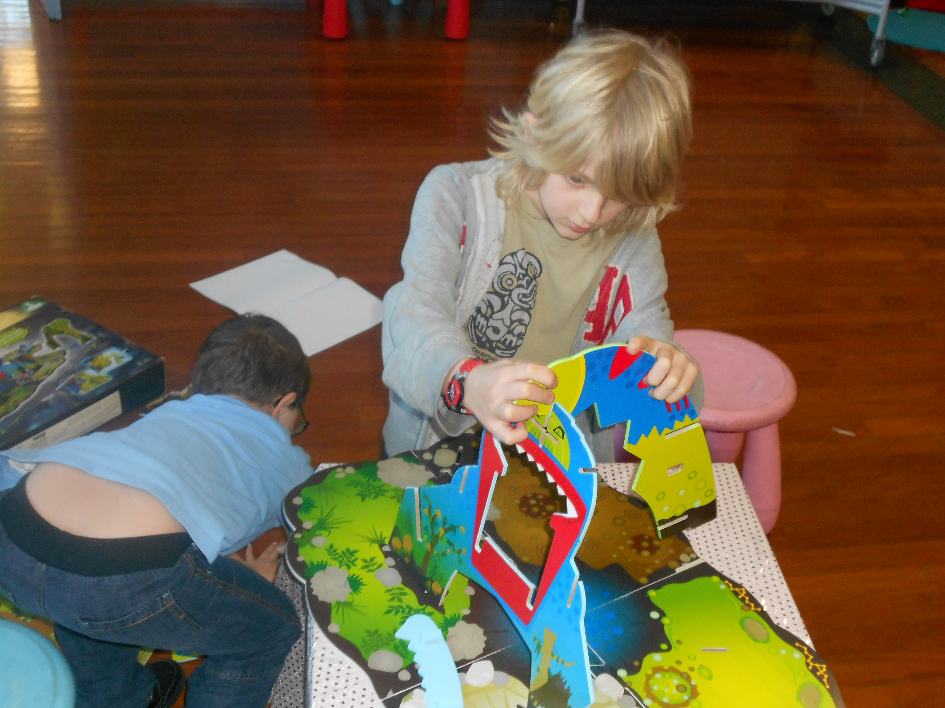
Rockets OOSC Limited currently has six members of staff, 3 members of staff will be present at the club on a daily basis 1 member of staff to every 8 children, the staff are as follows:

Kate Fletcher – Coordinator
Melanie Hicks – Deputy Coordinator
Sue Heydon – Playworker
Harriet Hall - playworker
Rheanna Sutton - Playworker
Jane McArthur – Playworker
Alison O’Dwyer – Playworker/ finance admin

All Rockets OOSC Limited staff attends regular training courses to extend their knowledge in childcare and education.

Arrivals and Departures

Rockets will give a warm and friendly welcome to each child on arrival and ensure that they depart safely at the end of each session. All children from Reception and year one will be collected at the end of the school day, all other children will make their own way up to Rockets.

Collection

When you arrive to pick up your child please ring the bell on the right hand side of the double security door (purple) which is situated by the ramp in the car park. This system ensures that no other persons other than your selves can enter our premises. Please make sure you sign your child/children out before leaving the club and also take any letters and all your children’s belongings. ROCKETS CLOSES AT 6PM, ANYONE ARRIVING AFTER THIS TIME WILL BE CHARGED ACCORDINGLY. (SEE LATE CHARGES)

Non Collection

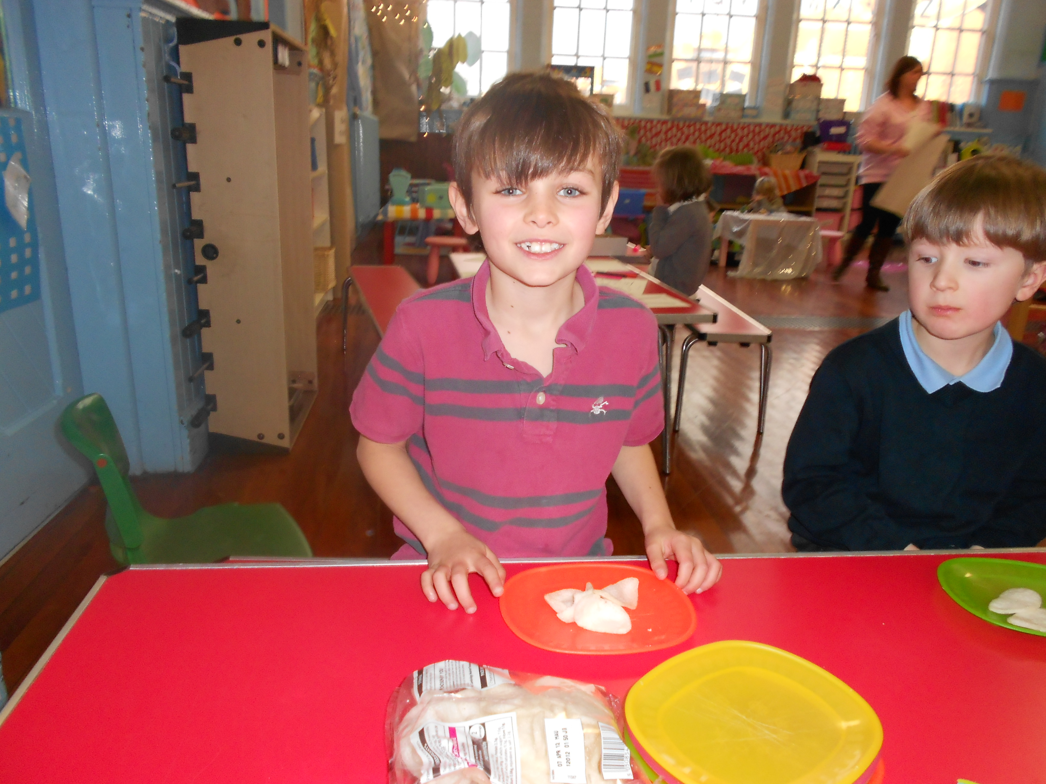
In the event of you failing to collect your child/children every effort will be made to contact you, failing this we will contact the other emergency contacts that you have provided. Falling all the above options the registered person will contact the local authority duty social worker.

Closing Rockets OOSC Limited in an emergency

In very exceptional circumstances, Rockets OOSC Limited may need to be closed at very short notice due to an unexpected emergency. In such circumstances the manager and staff will ensure that all steps are taken to keep both the children and themselves safe.

Illness

If your child is ill we ask that they do not attend the club, if a child is ill during their time with us you will be called and asked to collect them immediately. Please do NOT send your child/children to Rockets following sickness and diarrhoea for at least 48 hours.

Infectious and Communicable diseases


If an infectious or communicable disease is detected on Rockets OOSC Limited premises, the club will inform parents/carers personally in writing as soon as possible. Rockets OOSC Limited are committed to sharing as much information as possible about the source of the disease and the steps to being taken to remove it. Ofsted will also be informed of any infectious or communicable diseases discovered on Rockets premises

Absences

If your child is not going to attend a session at Rockets OOSC Limited please inform us as soon as possible, this can be done by a note in Rockets pigeon hole or by using the contact number provided 07547670230. Cancelled places still have to be paid for even if your child does not attend. A text can be sent to let us know your child is not attending.


Medication

Rockets OOSC Limited has a policy not to administer medication to any child/children in our care. All children with inhalers must have them with them at Rockets OOSC Limited. All staff at Rockets OOSC Limited are First Aid qualified and will act efficiently and accordingly to any accident or emergency.

Accidents


Active children are always getting into bumps and scrapes. If an accident should occur whilst in our care the appropriate action will be taken. Every accident will be logged in the accident book accurately. You will be asked to sign the form stating that you are happy with the way we dealt with the accident if we feel the parent should be contacted we will do so. If the injury occurred during the school day the teachers will pass on to us the bump form with an explanation of the accident and procedure followed.

First Aid


Rockets OOSC Limited are committed to encouraging and promoting good health and to dealing efficiently and effectively with illness and emergencies that may arise while children are in our care. Under the duties set out in the Health and Safety (First Aid) regulations 1981, Rockets recognises its responsibilities in providing adequate and appropriate equipment, facilities and personnel to enable suitable First Aid the be given at the club. Five members of our staff are First Aid trained.

Sun Protection


The manager and staff understand the dangers posed to children by over exposure to the sun, parents are encouraged to send their child/children into school with appropriate protective sun clothes. Staff may apply sunscreen to children with parents/carers written permission



Food and Drink

If your child/children have any dietary requirements please inform us, also any allergies. It is very important that you provide this information.

(NO NUTS POLICY)

Fire Procedure

In the event of a fire the children in the club will be evacuated immediately. Regular fire drills are carried out every 12 weeks and all new children will be made aware of our fire procedure.

Health and Safety


Rockets OOSC Limited takes the maintenance of health and safety extremely seriously matter of both legal and moral importance. Our club aims to ensure the health, safety and welfare of all staff, children and visitors and other individuals who may be affected by the club’s activities and actual existence.

Risk Assessment


We understand the importance of ensuring that systems are in place for checking that Rockets OOSC Limited is a safe and secure place for children, staff and other visitors. Our Risk assessments procedures are part of continuous process to prevent any dangerous incident taking place. They are the responsibility of all staff as part of their daily duties.

Site Security

Rockets OOSC Limited are committed to providing care learning and play in a safe and secure environment. All staff has an individual and collective responsibility to ensure that they have continuous regard for the safety and security of all children at the club at all times.

Physical Environment

Rockets OOSC Limited are committed to providing children with a stimulating and safe environment. We will do all we can to make our premises welcoming and friendly to children, parents/carers and any other visitors.

Hygiene

Rockets OOSC Limited recognises the importance of maintaining the highest possible standards of hygiene in and around the premises so as to minimise the risks posed to children, staff and visitors. All staff at Rockets OOSC Limited are committed to taking practical steps to prevent and control the spread of infectious germs, and to uphold high standards of hygiene in order to minimise the risk of catching or spreading infectious.

Child Protection

Rockets OOSC Limited follows the 1989 children’s act and complies with the child protection procedures. All staff have received child protection training to raise their awareness of any kind of abuse and knowledge of appropriate child protection procedures.


Equal Opportunities

Rockets OOSC Limited is committed to taking positive and proactive steps to ensure that we provide a safe and caring environment, free from discrimination, for everyone in our community.

Anti Bullying

Rockets OOSC Limited is committed to providing an environment for children that is safe, welcoming and free form bullying. Bulling of any form is unacceptable in our club, whether the person involved is a child or an adult.

Special Needs

Rockets OOSC Limited are aware that some children have special educational needs and/or physical disabilities that require particular support and assistance. We are committed to taking appropriate action to make sure that all children are able to access our services, made to feel welcome, and that our activities promote their welfare and development.

Behaviour


Certain types of behaviour are not acceptable at Rockets OOSC Limited and will be dealt with by staff accordingly. Guidelines are laid down by club staff and are explained to the children who attend the club so that they are aware of behaviour codes. We have Rockets Rules which all children and staff have signed that they will abide by. Also we use the same behaviour chart as the school by starting our children on green and if they show exceptional behaviour they will be moved up to silver or gold, if they misbehave the first warning is to move to orange then if it happens agin they move to red where they will be given time out and parents and teachers will be informed.

- If any child acts in an unreasonable manor a member of staff will take the child to one side and explain that their behaviour is not acceptable and move them to orange,
- If the child continues to behave in the same manor possibly upsetting or harming others the child will be asked to sit on the ‘thinking mat’ activity and not allowed to return until their behaviour is moderated and they will be moved to red.

Physical punishment in any form will not be used and no child will ever feel frightened or humiliated by anyone at Rockets.

Complaints


Should a complaint need to be made regarding Rockets OOSC Limited or its staff you can do this my speaking to the club Co-ordinator kate Fletcher directly or by e mail rocketsooscltd@hotmail.co.uk, or you can contact the Rockets OOSC Limited Directors by leaving a letter in the pigeon hole addressed to the Chair of Rockets OOSC Limited. All complaints will be dealt with within 72 hours. If you do not wish to put the complaint through the club you can contact Ofsted directly.

Children’s Belongings

We ask that all children bring all their belongings along to the club this includes letters, book bags, lunch boxes, water bottles and coats etc…

Lateness



If you are going to be late collecting your child/children please notify us immediately you can do this by calling on 07547670230, you will be charged £3.20 after 4pm £1.70 if you are late after 5pm, and £4 for every five minutes that you are late after 6pm per child. For example 6.00pm -6.05pm = £4 per child, 6.05pm - 6.10pm = £8 per child and so on.

If you are unable to collect your child/children we will need a full description of the person who will be collecting them, under no circumstances will we release a child into the care of an unknown person. If you have any problems or matters you wish to discuss concerning your child/children Rockets OOSC Limited we will be happy to talk to you.


Payment Details

At Rockets we charge as follows:
If your child stays until 4 o’clock - £3.50
If your child stays until 5 o’clock - £6.70
If your child stays until 6 o’clock - £8.40
Before school club-£3.50 per morning.

If you are late after 4pm you will be charged for the 5pm session - £3.20 extra PER CHILD
If you are late after 5pm you will be charged for the 6pm session - £1.70 extra PER CHILD

If you are late after 6pm an extra £4 for every five minutes you are late will be charged to you. PER CHILD for example 6.00PM – 6.05PM =
£4 PER CHILD, 6.05PM - 6.10PM = £8 PER CHILD AND SO ON.

If you wish to use Rockets as a one off you must pay for the session in advance before your child attends or when you collect your child that day.
All booked places for your child must be paid for.

If your child is absent and does not attend their designated session, you will still be charged for this session.
Any additional sessions besides your child’s normal sessions must be paid for as an extra. For example a Monday swapped for a Tuesday will be charged as an extra sessions.

Fees for Rockets OOSC Limited must be paid within five days of the start of each half term. The date for the due payment will be stated on your bill.
If any bills are not paid by the date stated will be classed as a late payment and the following penalties will be incurred:

- £10 penalty charge for payment not received within 5 days of the start of each half term.
- £1 penalty charge for each day after the fees are overdue.
- If the fees are not paid within a further 5 day period, your child/children’s places at the club will be reallocated.

All Cheques should be made payable to ROCKETS OOSC LIMITED

We are happy to accept payments direct into our bank account, but in this case Payments must be made on the first day of that half term to allow time for the payment to be credited to our account before the due date. This will avoid you being charged the penalty charges for late payment. If you are having difficulties paying your bill in full please speak to Kate Fletcher as she may be able to offer you an agreed payment plan, however if a plan is made an not adhered to a penalty charge will be added to your account.

Place cancellation
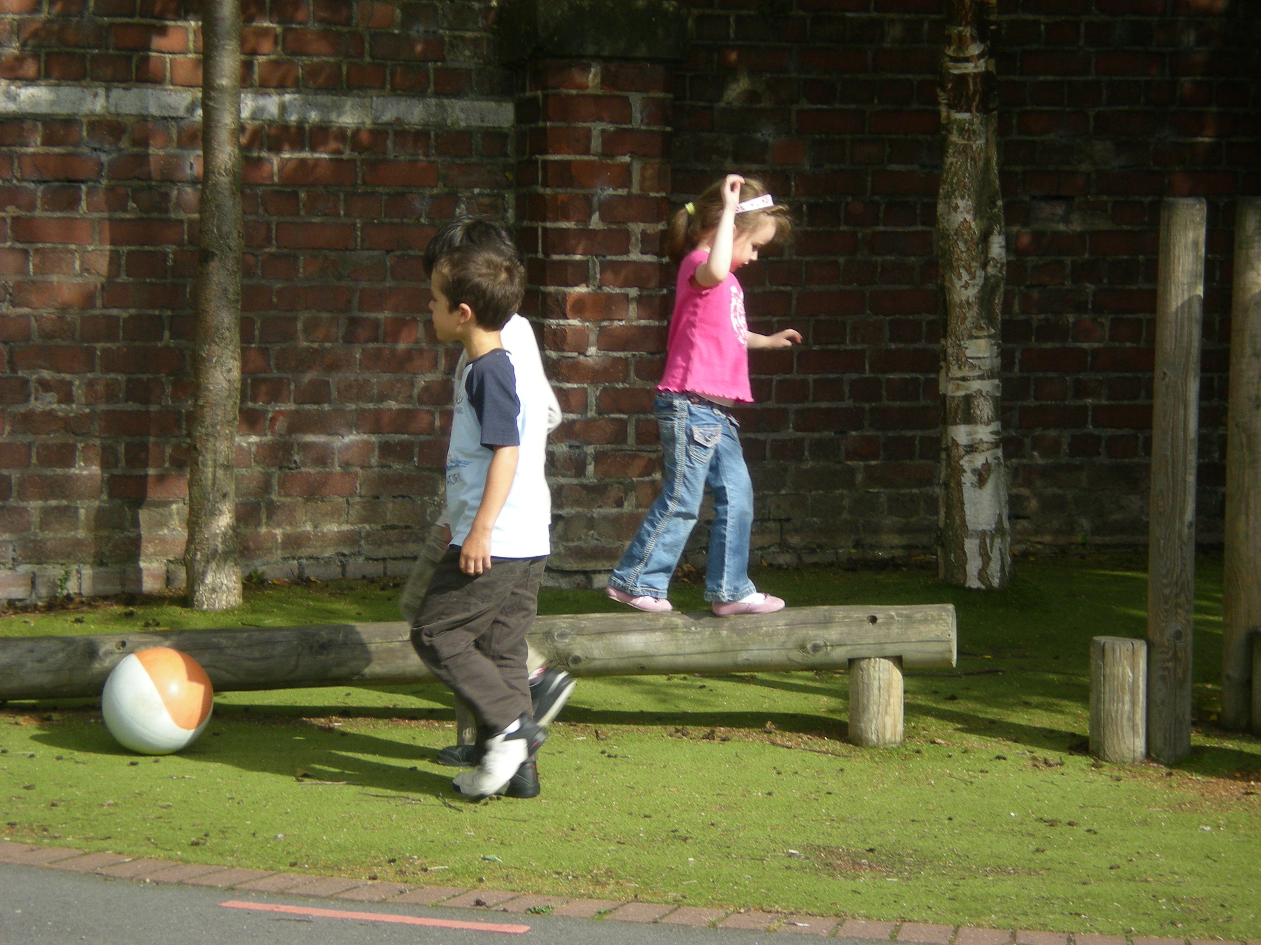
If you wish to cancel your child’s/children’s place a notice period of one month must be given in writing, you will be charged for the months notice period.

Committee Details

Rockets OOSC Limited is run by a voluntary committee, these consist of parent volunteers and we call them Directors. Rockets is a non profit making organisation, the committee and staff meet once every half term to discuss any arising matters, if you are interested in joining us please feel free to come and speak to us at any time, we value our parents and rely on your support without volunteers the club would not exist. We always welcome new faces to join us.
Thank you for taking the time to read through the information about our club, we look forward to meeting and getting to know your child/children.

Please fill in the parent agreement on the next page and return to us before your child starts at the club (if your child/children already attend Rockets please fill in and return as soon as possible) please do not hesitate to contact us at any time if you have further questions our contact number is 07547670230

Rockets OOSC Ltd Team ☺

…………………………………………………………………………………………………………………………………………………………………………

PARENTAL AGREEMENT

I have read the Rockets OOSC Limited parent pack and I understand that I must adhere to the rules and regulations of the club.

Signed…………………………………………………………. Date…………………………………………………………….
Name of child………………………………………………….
Relationship to child………………………………………

