Early Years Knowledge Organiser: Our Busy Bodies! 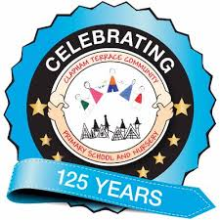
Autumn 1, 2020
Key questions: What is my body made from? How does it work? How can I keep my body healthy? Is my body the same as yours?
Humans have five basic senses: touch, sight, hearing, smell and taste. The sensing organs associated with each sense send information to the brain to help us understand the world around us.
To help keep our bodies fit, strong and healthy we can eat a balanced and varied diet, drink plenty of water, exercise every day, clean our teeth, and lots more! What else can you think of…?

